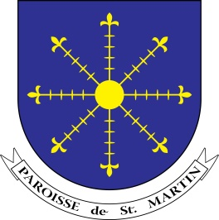
ST. MARTIN’S PRIMARY SCHOOL

Mrs C Mason St Martin’s Primary School

Headteacher Route des Coutures
St Martin
GUERNSEY
Telephone: (01481) 756060 GY4 6HN
Email: office@stmartins.sch.gg
Website: www.stmartins.sch.gg

13 September 2016

Dear Parents/Carers

Code Club

This year we will be offering Code Club to children from Years 4 and 5.

We will be introducing children to a coding programme called Scratch which has been designed primarily for 8-16 year olds. We follow step by step activities, designed by an organisation called Code Club, which help children to create their own interactive games whilst learning about the different aspects of coding. Learning to code helps children to analyse and solve problems. It also encourages creative thinking and collaboration.

Code Club will run on Thursdays from 3 - 3.45pm, beginning on Thursday 22nd September.

If your child would like to attend Code Club, please fill in the form below and return it to Mrs Karia. Please note that we may need to limit numbers depending on demand so places will be allocated on a first come basis.

Yours faithfully

Mrs Bramley and Mrs Karia
ICT Co-ordinators

------------ - - - - - - - - - - - - - - - - - - - - -- - - - - - - - - - - - - - - - - - - - - -- - - - - - - - - - - - - - - - - - - - - -- - - - - - - - -- - -
CODE CLUB

Please return to Mrs Karia:

Child’s Name: ___________________________________________ Year: _______________________

I give permission for my son/daughter to attend the Tuesday afterschool Code Club.

Sign: _________________________________________________ Date: _____________________

Print: ______________________________________________

