RSPB BIG GARDEN BIRDWATCH WITH THE BIRD BOX!
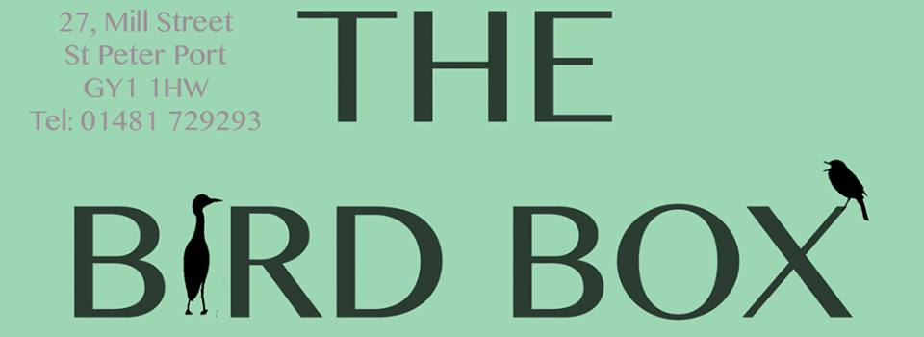
WIN £100 TO SPEND AT THE BIRD BOX IN MILL STREET
With
Play along all next week 23rd – 27th for your chance to win
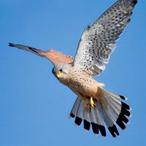
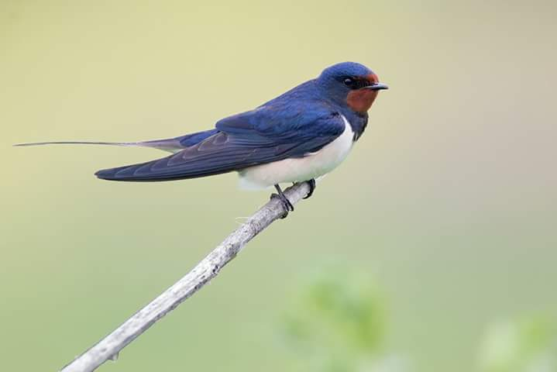
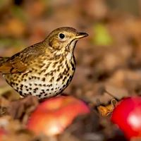
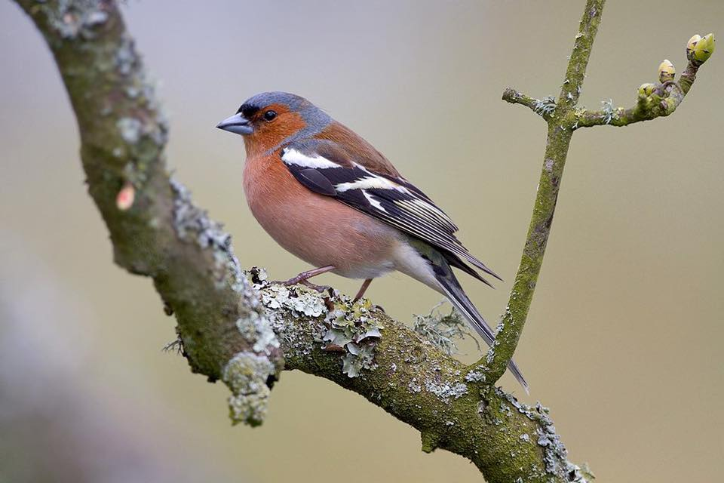

We’d love all local schools to get involved in this competition – it’s a great way to get the children out and about in their gardens and surrounding areas… practice their photography skills and also win a fantastic prize!
Simply take a photo of any kind of bird you spot and e-mail the photos to bird@islandfm.com to be in with a chance of winning!
All entries must be received by the 27th January 2017

