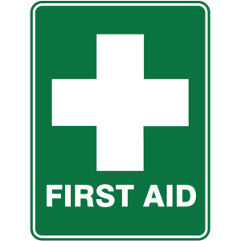
First Aid Club: Years 4, 5 and 6

Dear parents/carers,

Mrs Milly Sarre and Mrs Sarah Staples, experienced St John’s Ambulance volunteers, are continuing to offer their experience and knowledge in running a First Aid Club. It is for years 4, 5 and 6 children and will run on a Wednesday from 3:00 to 4:00 in the Music and Drama Room. The first session will begin next week 21st September and run until further notice.
Please fill in the permission slip below and return to Mrs Staples as soon as possible if your child would like to attend. Please note there is a limit on numbers so there will be a first come, first served basis. Any queries please pop in and see me or drop me an email at Sarah.staples@stmartins.sch.gg
Kind regards
Mrs Staples

--------------------------------------------------------------------------------------------------
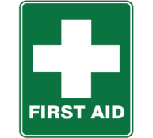
I give permission for ____________________________________(child’s name)
Class____________________to attend First Aid classes.
Arrangements for picking up: ___________________________________________________________

Signed:_____________________________ Child’s class: __________________

