YEAR 5 and 6
NETBALL CLUB
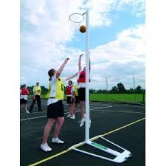

Wednesdays 3 – 4pm
on the All Weather Pitch.
Trials take place on Wednesday 13th, 20th and 27th September.
Please speak to Miss Green if you wish to join.

