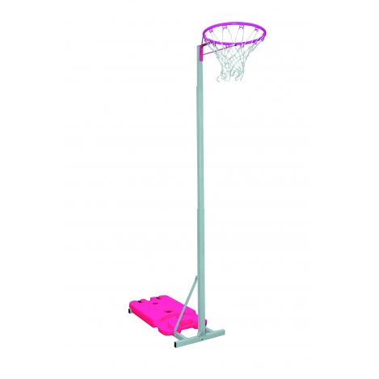

*“This information is provided for the interest of members of the community. The circulation of the information should not be taken as a recommendation or endorsement by the school or Education Department and you should carry out your own enquiries to ensure that you are satisfied with the quality, suitability and safety of the product or service advertised and the identity and character of those providing it.”* ***States of Guernsey Education Department***

**Current School Year 7 (Starting in Sept 2018)**

**Day:** Thursday (Weekly)

**Start Date:** 6th September 2018

**Time:** 17.30-19.00

**Venue:** Beau Sejour Indoor Sports Hall

**Coaches:** Heidi Rosamund, Clare Henry & Kim Le Lacheur

**Team Manager:** Natalie Chamberlain

**Cost:** £20 per month

**GUERNSEY PANTHERS**

**YEAR 7 NETBALL**

**TRIALS**

**2018/19**

**Eat, Sleep, Netball Repeat ☺**

**Develop your netball skills or learn something new!**

**Please return the slip by Thursday 30th August 2018**

**Please note if the permission slip is not provided prior to the start date your child will not be able to participate.**

I hereby give permission for _____________________ to attend the netball sessions at Beau Sejour. I hereby give permission for photographs/videos of my child to be used for publicity purposes. These materials will be used in line with the Guernsey Netball Association safeguarding children policy.

**Name of child** **Age** ___

**Medical Information**  Details:

**Emergency Contact** Name: **Tel**: _________

Email: ___________________________________

Has your daughter played netball before? Yes/No if yes, what is her preferred position/s?

Please return this slip by email to Natalie Chamberlain @ [Natalie.Chamberlain@lts-tax.com](mailto:Natalie.Chamberlain@lts-tax.com)

Cheques are to be made payable to Guernsey Panthers or Bank Transfer to S/C 30-93-73 A/C 28849768 **Ref U12 + child’s name.**